Lab 3 Pre-lab Brian Taylor (52311859)

1. A 1-of-4 multiplexer made from three 1-of-2 multiplexers.

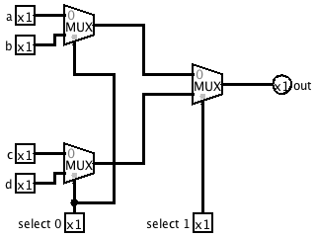

2. i) The corresponding circuit for ~(~(a ∧ b) ∧ ~(c ∧ d)) made with NAND gates only.

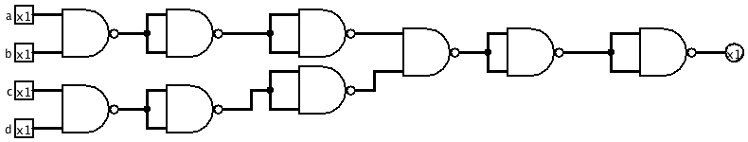

Since there are a few inverters in sequence these can be removed for a much simpler circuit.

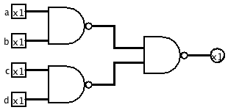

ii) The corresponding circuit for ~(a ∧ ~(b ∧ ~(c ∧ d))) made with NAND gates only.

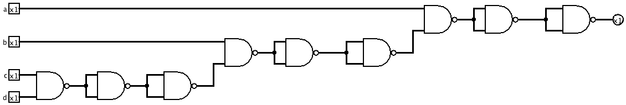

And, once again, removing sequential inverters results in the simpler circuit.

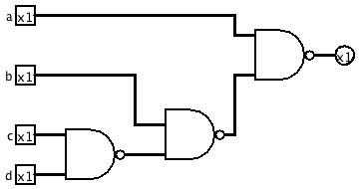

These circuits and their corresponding equations are not equivalent. Their truth tables are different.

